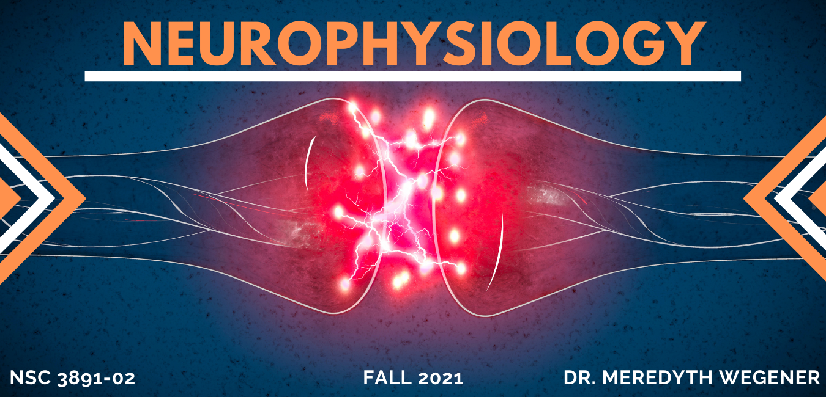

Course Description:
In this course we will examine the functioning of neurons, the basic units responsible for fast communication within the nervous system. The course will focus on the elegant use of electrical mechanisms by the nervous system, and on the powerful quantitative approach to scientific investigation that is fundamental to neurophysiology. Topics that will be addressed include: principles of electric current flow exploited by the nervous system; the basis of the resting potential of neurons; the structure and function of voltage-gated and neurotransmitter-gated ion channels; generation and propagation of action potentials; the physiology of fast synaptic communication, design of electrophysiological experiments, ans interpretation of electrophysiological data.

Educational Objectives/Goals:
- Understand how the principles of physics apply to neurons and their function.
- Design electrophysiological experiments & interpret the subsequent data.
- Compare and contrast the ionic basis of resting membrane potential and the action potential.

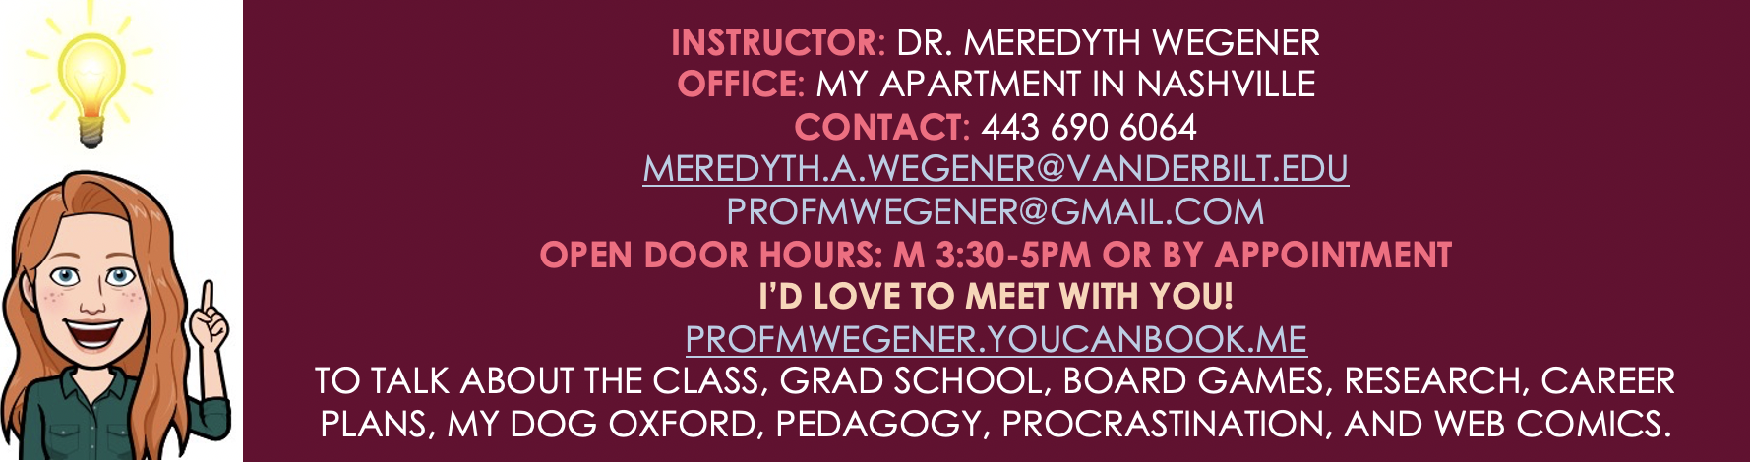

Students who complete this course will be able to:
- Demonstrate knowledge of and the ability to apply the learning objectives above.
- Be able to work effectively in a team and in a group to solve problems
- Think like a scientist and dive deep into a scientific problem on one’s own or as a team
  - Become familiar with scientific methodology including an understanding of commonly used methods for studying neuronal function in different model systems.
  - Be able to evaluate a scientific study by identifying: hypothesis being tested, assumptions made, expected outcomes, data and analysis, interpretation of results, link to hypothesis, and follow-up questions to ask.

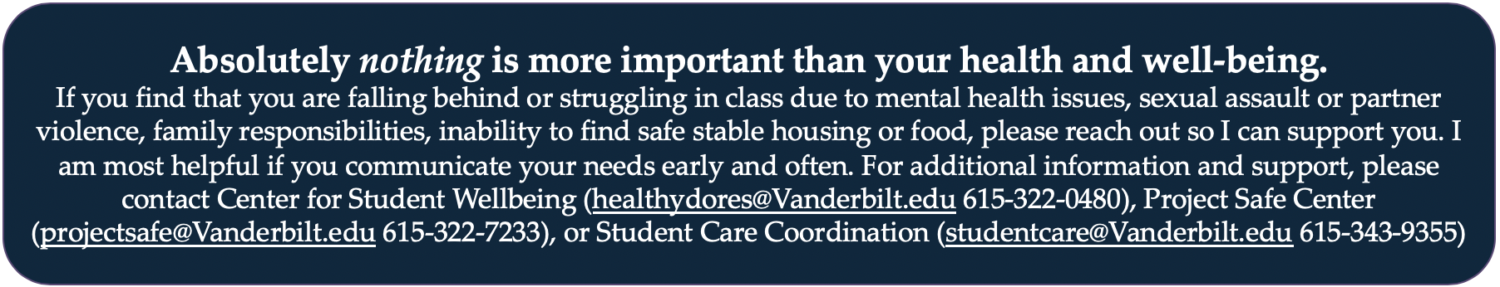

Ability and Disability (as taken from Vanderbilt’s Center for Teaching): This class respects and welcomes students of all backgrounds, identities, and abilities. If there are circumstances that make our learning environment and activities difficult, if you have medical information that you need to share with me, or if you need specific arrangements in case the building needs to be evacuated, please let me know. I am committed to creating an effective learning environment for all students, but I can only do so if you discuss your needs with me as early as possible. I promise to maintain the confidentiality of these discussions. If appropriate, also contact Student Access Services to get more information about specific accommodations.

Responsibilities as a member of this course: It is entirely your choice to take this course. If you do opt to join our classroom community, it is expected that you will be respectful of all members of our community and listen thoughtfully to their contributions, questions, and confusion. Expressing your thoughts or concerns is essential for your learning and helpful for your classmates. In return, we will strive to create a valuable learning environment/ experiences for you and ensure that you are heard and treated respectfully as well. If you feel there is something we could be doing to improve your learning or capture your interest, we welcome your feedback in person, through email, or anonymously.

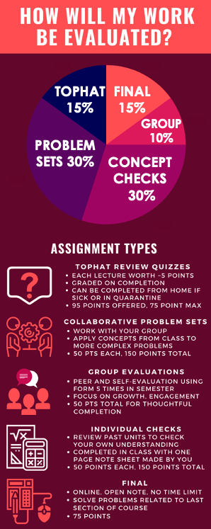
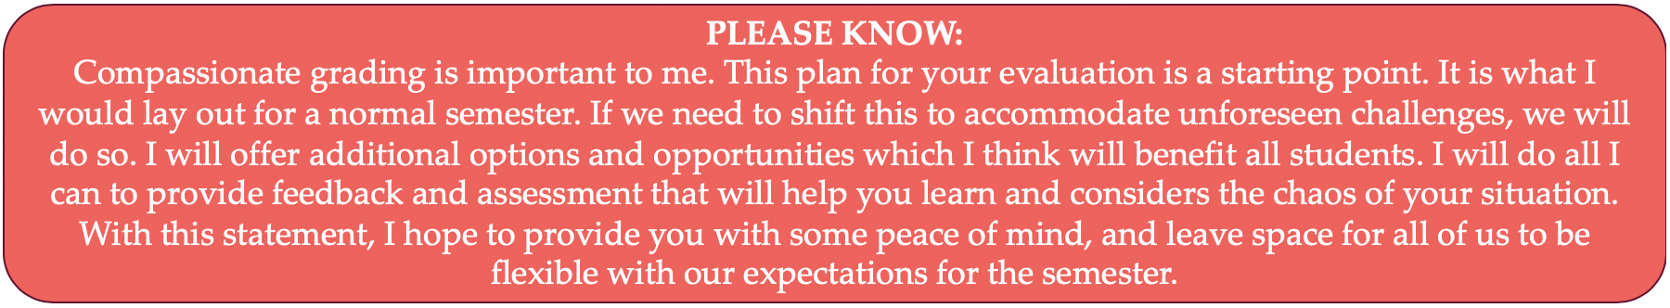
Groups

You will work in groups of 3 throughout the semester. You will work with randomly generated groups until add/drop at which time you will pick a group for the rest of semester. You will evaluate yourself and you group members 5 times through the semester. Theis will be completed and submitted on Brightspace.

My hope is that by having feedback on group dynamics and time for reflection across the semester, we can work together in the best manner possible. All assignments will be individual, but your group will be your mini class community.

Top Hat
We will be using the Top Hat (www.tophat.com) classroom response system in class. You will be asked to answer questions during our synchronous meeting. If you you do not feel well, please stay home and follow along with class from home if you are able. However, if you decide to use class time to pursue other interests or academic comittments, please do not answer the TopHat questions. You can miss 20 points of TopHat questions before your grade is affected, so no need to worry if you miss some or lose track once or twice. You can visit tinyurl.com/TopHatStudentGuide for the Student Quick Start Guide which outlines how you will register for a Top Hat account, as well as providing a brief overview to get you up and running on the system. An email invitation has been sent to your school email account (if you didn't receive this email, you can register by visiting our course website: https://app.tophat.com/e/176894 ).

Collaborative Problem Sets
There will be 3 Collaborative Problem Sets (CPS) designed to provide students with experience in solving problems. These problem sets are essential to the learning and application of class material. You are encouraged to work in your groups to discuss the concepts behind the problem and/or approaches to solving problem sets. However, you must complete the solutions to the graded problem sets independently. Identical / copied problem sets will be considered a violation of the Honor code. All due dates can be found on Brightspace and can be adjusted if necessary. The sooner you let me know, the better.

Academic Integrity:
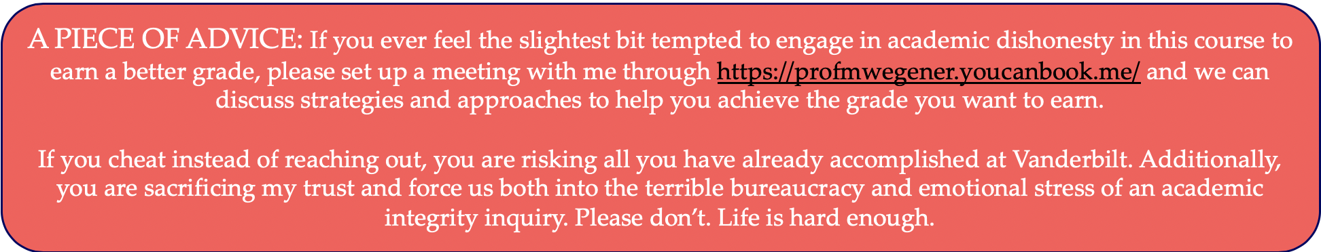
Vanderbilt’s Honor Code governs all work in this course. If you have any questions about how the Honor Code applies, please ask Dr. Wegener -- not another student or the T.A. -- for clarification. Uncertainty about the application of the Honor Code does not excuse a violation. Anyone who violates the Vanderbilt Honor Code will be dealt with as the Honor Council deems appropriate. There are no exceptions.

